Corrosion

What is Corrosion?
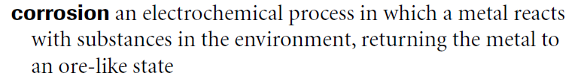
Corrosion is the deterioration of a metal as a result of chemical reactions between it and the surrounding environment.
Rusting is an example of corrosion, which is a spontaneous redox reaction of materials with substances in their environment.
Both the type of metal and the environmental conditions, particularly what gases that are in contact with the metal, determine the form and rate of deterioration.

In General
A galvanic couple forms between the two metals, where one metal becomes the anode and the other the cathode. The anode corrodes and deteriorates faster than it would alone, while the cathode deteriorates more slowly than it would otherwise.
Three conditions must exist for galvanic corrosion to occur:
- Electrochemically dissimilar metals must be present
- The metals must be in electrical contact
- The metals must be exposed to an electrolyte

Galvanic Corrosion
Galvanic Corrosion occurs when 2 different metals are located together in a corrosive electrolyte. Remember, an electrolyte is an “aqueous electrical conductor”, and the most common electrolyte is water (H₂O).
However, water itself is a neutral compound. For water to become an electrical conductor, there must be a presence of ions. Therefore the most common electrolyte is not just water; it’s rain water.
Most metals have different electrical potentials.
When connected electrically and placed in an electrolyte,
- the more active metal becomes the anode because:
  - it has more negative potential
  - corrodes faster than if it were alone in the environment

- the more noble (less active) metal becomes the cathode because:
  - it has more positive potential
  - corrodes at a slower rate than if it were alone in the environment
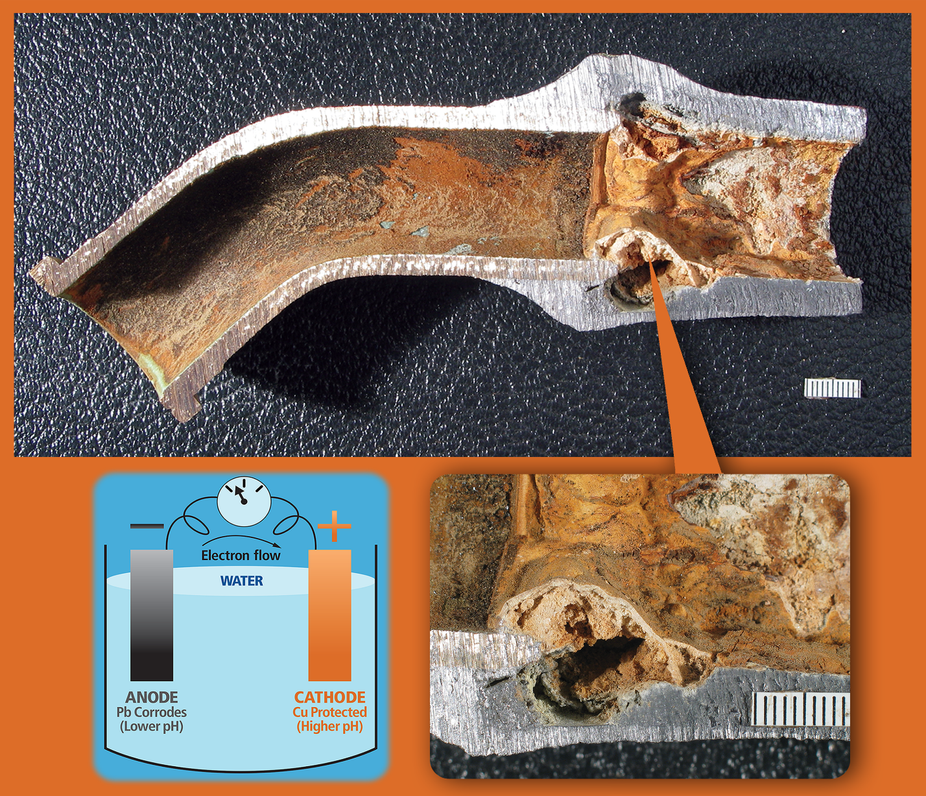

Rusting of Iron
Iron corrodes in the presence of both O₂ and H₂O, where Iron is converted into iron oxides and hydroxides. The reaction is not unlike any other galvanic cell reaction, and is solved in the same manner.

Iron (II) ions diffuse through the water on the iron surface while the electrons easily travel through the iron metal, which is an electrical conductor.
Rust is a hydrated iron(III) oxide, Fe₂O₃ • xH₂O.
- Equation 1: Cathode (Oxidizing Agent)
$$E^{o}=+0.44 {\text{O}}_{\text{2 (g)}}\text{+ 2 }{\text{H}}_{\text{2}}{\text{O}}_{\text{(l)}}\text{+ 4}{\text{ e}}^{\text{-}}\text{→2}{\text{ OH}}^{\text{-}}$$
- Equation 2: Anode (Reducing Agent)
$E^{o}=-0.401 {\text{Fe}}_{\left(\text{aq}\right)}^{\text{2+}}\text{ + 2}{\text{e}}^{\text{- }}\text{→ }{\text{Fe}}_{\text{(s)}}$ $E^{o}=+0.401 {\text{Fe}}_{\text{(s)}}\text{ → }{\text{Fe}}_{\text{(aq)}}^{\text{2+}}\text{ + 2}{\text{ e}}^{\text{-}}$
- Balancing e⁻
$E^{o}=+0.401 \text{2 ∙ (}{\text{Fe}}_{\text{(s)}}\text{ → }{\text{Fe}}_{\text{(aq)}}^{\text{2+}}\text{ + 2}{\text{ e}}^{\text{-}})$ $E^{o}=+0.401 \text{2 }{\text{Fe}}_{\text{(s)}}\text{ → }\text{2 }{\text{Fe}}_{\text{(aq)}}^{\text{2+}}\text{ + }\text{4}{\text{ e}}^{\text{-}})$
- Anode + Cathode
$$\text{∆}{\text{E}}^{\text{o}}\text{= }\text{+0.841 }\text{ 2 }{\text{Fe}}_{\text{(s)}} \text{+ }{\text{O}}_{\text{2 (g)}} \text{+} \text{2 }{\text{H}}_{\text{2}}{\text{O}}_{\text{(l)}} \text{+} \text{4 }{\text{e}}^{\text{-}}\text{→ 2 }{\text{Fe}}_{\left(\text{aq}\right)}^{\text{2+}} \text{+} \text{4 }{\text{OH}}^{\text{-}} \text{+} \text{4 }{\text{e}}^{\text{-}}$$
- Final Equation
$$\text{∆}{\text{E}}^{\text{o}}\text{=} \text{+0.841 2 }{\text{Fe}}_{\text{(s)}} \text{+ }{\text{O}}_{\text{2 (g)}} \text{+} \text{2 }{\text{H}}_{\text{2}}{\text{O}}_{\text{(l)}}\text{→ 2 }{\text{Fe}}_{\left(\text{aq}\right)}^{\text{2+}}\text{+} \text{4 }{\text{OH}}^{\text{-}}$$
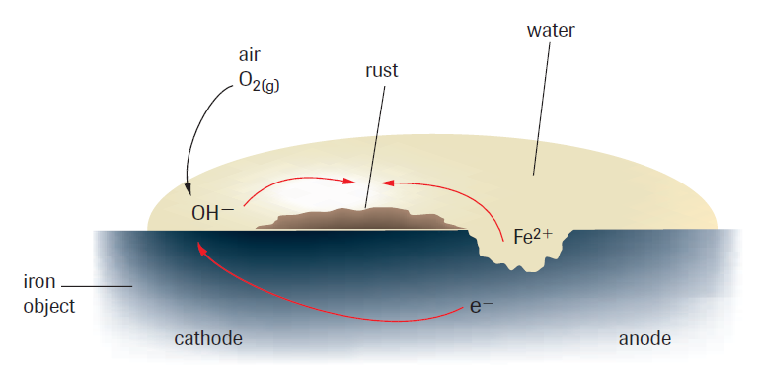
Water, in the form of rain, is needed for rusting to occur. Carbon dioxide in the air dissolves in water to form carbonic acid, ${\text{H}}_{\text{2}}{\text{CO}}_{\text{3 (aq)}}$. This weak acid partially dissociates into ions. Thus, the carbonic acid is an electrolyte for the corrosion process. Other electrolytes, such as road salt, may also be involved. The circuit is completed by the iron itself, which conducts electrons from the anode to the cathode.

$$\text{Cathode:} {\text{O}}_{\text{2 (g)}}\text{+} \text{2} {\text{H}}_{\text{2}}{\text{O}}_{\text{(l)}}\text{+} \text{4}{ \text{e}}^{\text{-}}\text{→2}{ \text{OH}}^{\text{-}} E^{o}=+0.44$$ | $$\text{Anode: }{\text{Fe}}_{\text{(s)}} \text{→} {\text{Fe}}_{\text{(aq)}}^{\text{2+}} \text{+} \text{2}{ \text{e}}^{\text{-}} E^{o}=+0.401$$

Final Equation | $$\text{∆}{\text{E}}^{\text{o}}\text{= +0.841 2 }{\text{Fe}}_{\text{(s)}}\text{ + }{\text{O}}_{\text{2 (g)}}\text{ + 2 }{\text{H}}_{\text{2}}{\text{O}}_{\text{(l)}}\text{→ 2 }{\text{Fe}}_{\left(\text{aq}\right)}^{\text{2+}}\text{+ 4 }{\text{OH}}^{\text{-}}$$

There is no barrier in the cell, so nothing stops the dissolved ${\text{Fe}}_{\text{(aq)}}^{\text{2+}}$ and ${\text{OH}}^{\text{-}}$ ions from mixing. The iron (II) ions produced at the anode and the hydroxide ions produced at the cathode react to form a precipitate of iron (II) hydroxide, $\text{Fe}{\text{(OH)}}_{\text{2}}$. Therefore, the overall cell reaction could be written as follows.
$$\text{2 }{\text{Fe}}_{\text{(s)}}\text{ + }{\text{O}}_{\text{2 (g)}}\text{ + 2 }{\text{H}}_{\text{2}}{\text{O}}_{\text{(l)}} → 2 \text{Fe}{\text{(OH)}}_{\text{2}\text{ (s)}}$$
The iron (II) hydroxide undergoes further oxidation by reaction with the oxygen in the air to form iron (III) hydroxide.
$$4 \text{Fe}{\text{(OH)}}_{\text{2}\text{ (s)}} + {\text{O}}_{\text{2 (g)}} + \text{2 }{\text{H}}_{\text{2}}{\text{O}}_{\text{(l)}} → 4 \text{Fe}{\text{(OH)}}_{\text{3}\text{ (s)}}$$
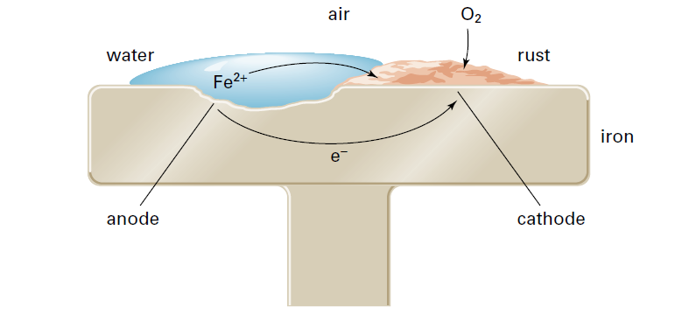
Iron (III) hydroxide breaks down to form hydrated iron (III) oxide, ${\text{Fe}}_{\text{2}}{\text{O}}_{\text{3}}$ • x${\text{H}}_{\text{2}}\text{O,}$ more commonly known as rust.
$2 \text{Fe}{\text{(OH)}}_{\text{3 (s)}}→ {\text{Fe}}_{\text{2}}{\text{O}}_{\text{3}}\text{ ∙ 3} {\text{H}}_{\text{2}}{\text{O}}_{\text{(s)}}$ Reddish-brown.
A rust deposit may contain a mixture of both of these compounds.

Prevention
In virtually all situations, metal corrosion can be managed, slowed or even stopped by using the proper techniques. Corrosion prevention can take a number of forms depending on the circumstances of the metal being corroded.
The simplest method of preventing corrosion is to paint an iron object. The protective coating of paint prevents air and water from reaching the metal surface. Grease, oil, plastic, or even other metals (typically less corrosive than iron) can also be used.

Examples
- A layer of chromium protects bumpers and metal trim on cars. An enamel coating is often used to protect metal plates, pots, and pans. Enamel is a shiny, hard, and very unreactive type of glass that can be melted onto a metal surface. A protective layer is effective as long as it completely covers the iron object. If there’s a break in the layer, the metal underneath can corrode.

- It is also possible to protect iron against corrosion by forming an alloy with a different metal. Stainless steel is an alloy of iron that contains at least 10% chromium, by mass, in addition to small quantities of carbon and occasionally metals such as nickel. Stainless steel is much more resistant to corrosion than pure iron. Therefore, stainless steel is often used for cutlery, taps, and various other applications where rust-resistance is important. However, chromium is much more expensive than iron. As a result, stainless steel is too expensive for use in large-scale applications, such as building bridges.
Some of the more complicated methods include:
- Galvanizing
  - Process in which iron is covered with a protective layer of zinc

- Cathodic Protection
  - Iron is forced to become the cathode of a cell, using either an impressed current or a sacrificial anode

