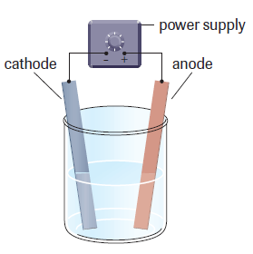
Electrolytic Cells

Electrolysis
Electrolysis  Electrolytic Cell | The process of supplying electrical energy to force a nonspontaneous redox reaction to occur  A cell that consists of a combination of two electrodes, an electrolyte, and an external power source (typically a battery)
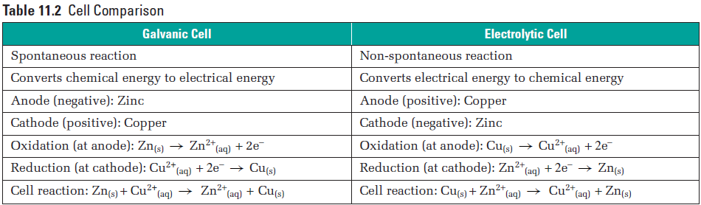
Galvanic Cells and Electrolytic Cells are, simply, opposites of each other. Where the GC is spontaneous, the EC requires an input of energy. Where the cell potential is positive for GC, it’s negative for EC. Where the Cathode is the positive electrode and the Anode is the negative electrode for GC, it’s the opposite for EC.

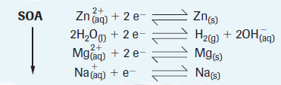
Production of Elements
Most elements occur naturally combined with other elements in compounds. Ionic compounds of sodium (Na), potassium (K), lithium (L), etc., are not found uncombined in nature, simply due to their oxidative potentials.
Ionic compounds can, and are, melted, yielding molten ionic compounds that are good electrical conductors and can function as the electrolyte in a cell. In the electrolysis of molten binary ionic compounds, only one oxidizing agent and one reducing agent are present. The production of active metals from their minerals typically involves the electrolysis of molten compounds of the metal.

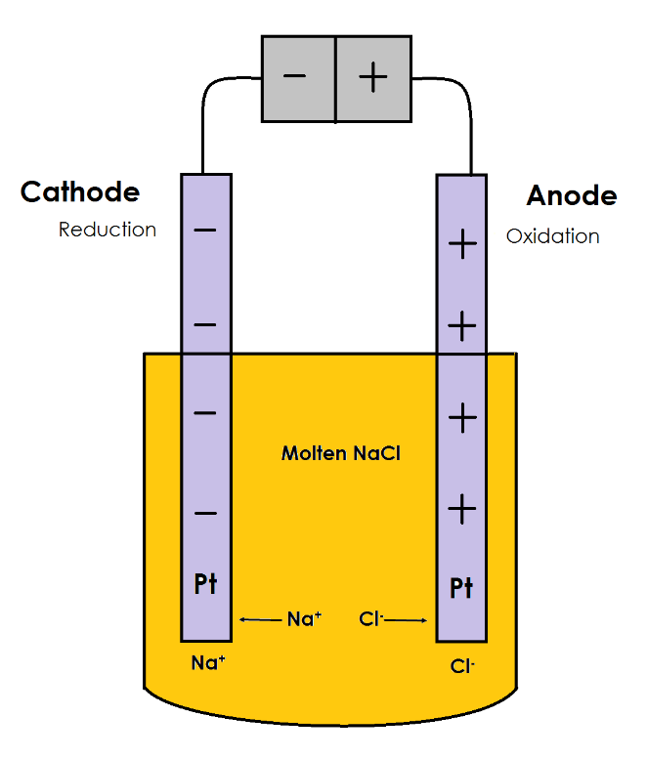
Electrolysis of Molten Salts

Cathode / Reduction / --‘ve
$${\text{Na}}^{\text{+}} \text{+} {\text{e}}^{\text{-}} \text{→} \text{Na} E^{o}\text{ = -2.7}\text{1}$$
Anode / Oxidation / +’ve
$$\text{2 Cl} \text{+} \text{2}{\text{ e}}^{\text{-}} \text{→} \text{2 }{\text{Cl}}^{\text{-}} E^{o}= +1.36$$
Final Equation:
$2\left[{\text{Na}}^{\text{+}} \text{+} {\text{e}}^{\text{-}} \text{→} \text{Na}\right] E^{o}=-2.71$
$$\text{2 }{\text{Cl}}^{\text{-}} \text{→} \text{2 Cl} \text{+} \text{2}{\text{ e}}^{\text{-}} { E}^{o}=-1.36$$
$$2 {\text{Na}}^{\text{+}}\text{+} \text{2 }{\text{Cl}}^{\text{-}}→\text{2 Na} \text{+} \text{2 Cl} E^{o}=-4.07$$

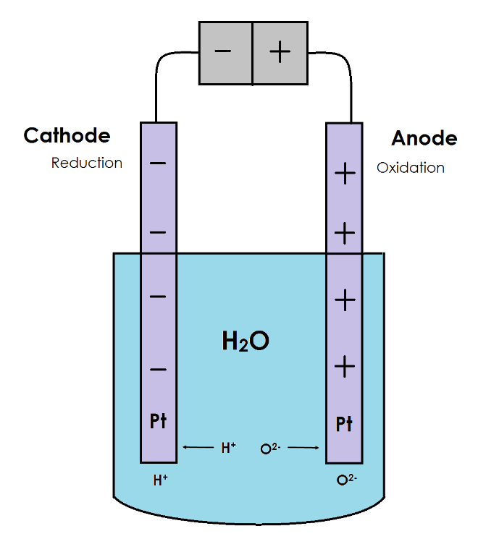
Electrolysis of Water

Cathode / Reduction / --‘ve
$$\text{2 }{\text{H}}_{\text{2}}\text{O + 2 }{\text{e}}^{\text{-}}\text{ → }{\text{H}}_{\text{2}}\text{ + 2 }{\text{OH}}^{\text{-}} E^{o}\text{ = -}\text{0.83}$$
Anode / Oxidation / +’ve
$${\text{O}}_{\text{2}} \text{+} \text{4 }{\text{H}}^{\text{+}} \text{+} \text{4 }{\text{e}}^{\text{-}} \text{→ } \text{2 }{\text{H}}_{\text{2}}\text{O} E^{o}= +1.23$$
Final Equation:
$2\left[\text{2 }{\text{H}}_{\text{2}}\text{O + 2 }{\text{e}}^{\text{-}}\text{ → }{\text{H}}_{\text{2}}\text{ + 2 }{\text{OH}}^{\text{-}}\right] E^{o}=-0.83$
$$\text{2 }{\text{H}}_{\text{2}}\text{O} \text{→} {\text{O}}_{\text{2}} \text{+} \text{4 }{\text{H}}^{\text{+}} \text{+} \text{4 }{\text{e}}^{\text{-}} { E}^{o}=-1.23$$
$$6 {\text{H}}_{\text{2}}\text{O}→\text{2 }{\text{H}}_{\text{2}} \text{+} {\text{O}}_{\text{2}}+\text{4 }{\text{H}}^{\text{+}}+\text{4} {\text{OH}}^{\text{-}} E^{o}=-2.06$$
$$2 {\text{H}}_{\text{2}}\text{O}→\text{2 }{\text{H}}_{\text{2}} \text{+} {\text{O}}_{\text{2}} { E}^{o}=-2.06$$

