Electrolytic Cells

Electrolysis of Aqueous Solutions

Steps
- Separate all of the “ingredients” within the solution into their respective ions
- Create 2 headings: “Cathode / Reduction / -‘ve” and “Anode / Oxidation / +’ve”
- Group all of the positive ions under “Cathode…” and all of the negative ions under “Anode…”
- If there are oxy-ion(s) (i.e. ${NO}_{3}^{-}, {ClO}_{4}^{-}, etc.$) present, calculate the oxidation charge for the non-oxygen element. If it possesses its highest oxidative charge, it cannot be further oxidized, and thus it becomes “useless” for the rest of the equation.
- It is imperative to identify this reality, as it can mislead you for the remaining portion of the question
- Identify reduction charges for each of the ions
- “Cathode…” Pick the ion with the highest reduction potential (i.e. -0.14 over -0.52, etc.)
- “Anode…” Pick the ion with the lowest reduction potential (i.e. +1.07 over +1.23 etc.)
- Solve
${\text{NO}}_{\text{3}}^{\text{-}}$ | x – 6 = -1  x= +5  Since, Nitrogen’s max oxidation number is +5, it cannot be further oxidized.

Example
In a solution with SnBr₂ and Al(NO₃)₃
Cathode/Reduction/-‘ve | $$E^{o}$$ | Anode/Oxidation/+’ve | $$E^{o}$$
Sn²⁺  Al³⁺  H⁺ | -0.14  -1.66  -0.83 | Br⁻  ${\text{NO}}_{\text{3}}^{\text{-}}$  O²⁻ | +1.07  X  +1.23
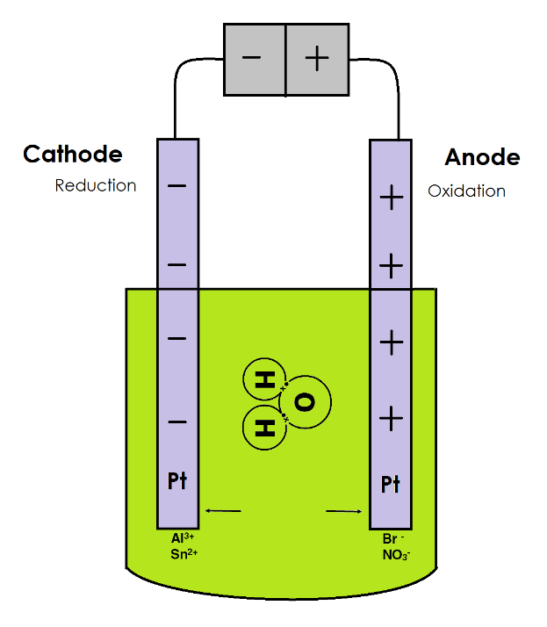
Cathode | Sn²⁺ because it has the highest reduction potential
Anode | Br ⁻ because it has the highest oxidation potential (lowest reduction potential)

2 Equations to be used:

$${\text{Sn}}^{\text{2+}} \text{+} \text{2 }{\text{e}}^{\text{-}} \text{→} \text{Sn }E^{o}= -0.14$$
$${\text{Br}}_{\text{2}} \text{+ } {\text{2 e}}^{\text{-}} \text{→ 2 }{\text{Br}}^{\text{-}} E^{o}= +1.07$$

$${\text{Sn}}^{\text{2+}} \text{+} \text{2 }{\text{e}}^{\text{-}} \text{→} \text{Sn }E^{o}= -0.14$$
$$\text{2 }{\text{Br}}^{\text{-}} \text{→}{ \text{Br}}_{\text{2}}\text{+ }{\text{2 e}}^{\text{-}} E^{o}= -1.07$$

$${\text{Sn}}^{\text{2+}}+ \text{2 }{\text{Br}}^{\text{-}}→ \text{Sn}\text{ +}{ \text{Br}}_{\text{2}} { E}^{o}=-0.61$$

