Galvanic Cells

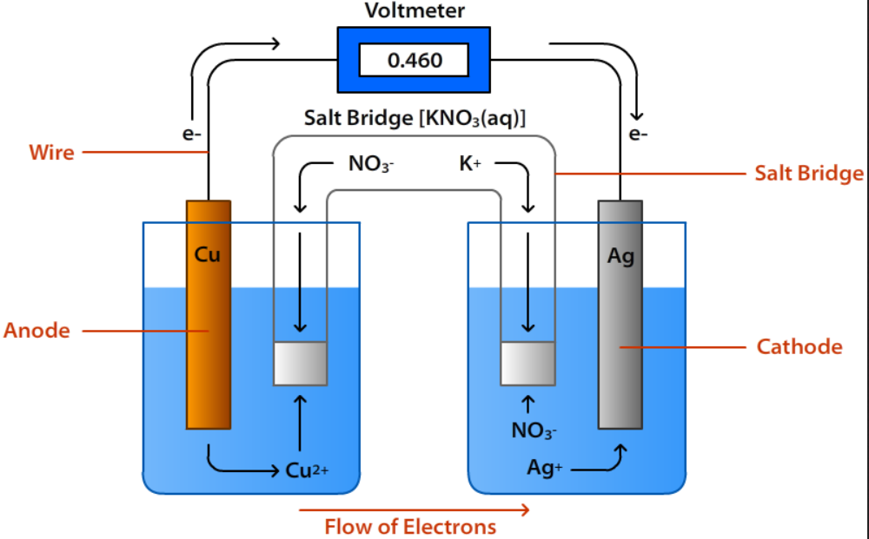
Volta’s Set-up of an electric cell
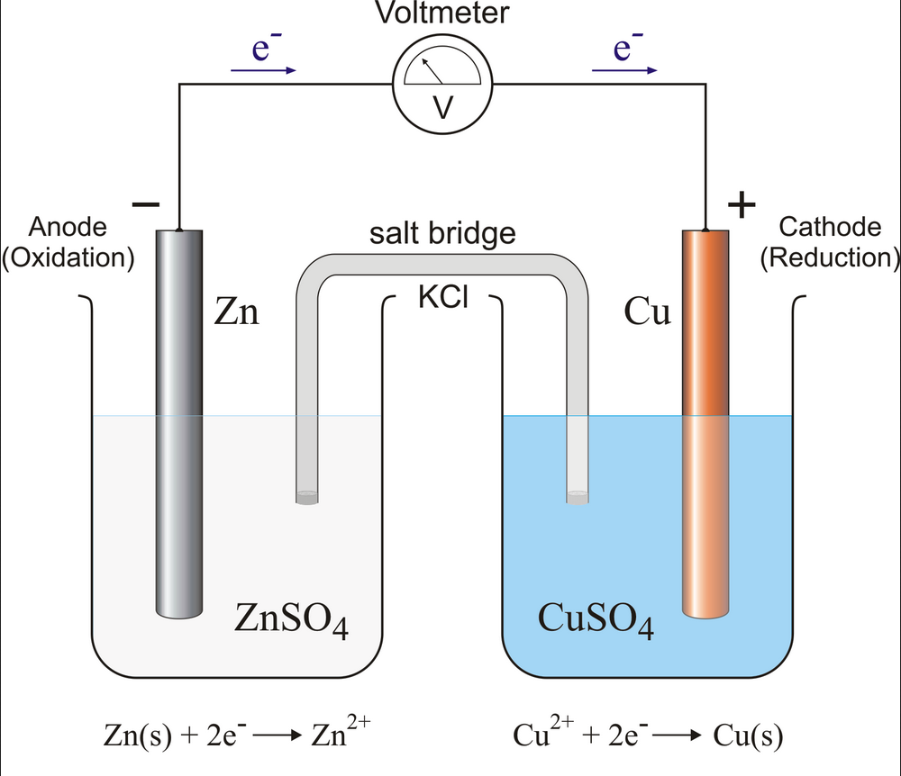

Definitions
Term | Definition
Electrochemistry | Reactions that produce (or is caused by) a flow of e⁻
Electric Cell | A device that continuously converts chemical energy into electrical energy
Electrode | A solid electrical conductor
Electrolyte | An aqueous electrical conductor
Voltage/Volt | Potential for e⁻ to go through a circuit  1 V 1 J/Coulomb  Volt The SI unit for electrical potential difference
Current/Ampere/Coulomb | Current Electrical current is a measure of the amount of electrical charge transferred per unit time. It represents the flow of electrons through a conductive material.  1 A 1 Coulomb/second  Ampere The SI unit for electrical current  Coulomb The SI unit for electrical charge
Half-Cell | An electrode and an electrolyte forming half a complete cell
Galvanic Cell | An arrangement of 2 half-cells that can produce electricity spontaneously
Cathode/Anode | Cathode (+) electrode where reduction occurs  Anode (-) electrode where oxidation occurs
Standard Reduction Potential | $∆E^{o}$ represents the ability of a standard half-cell to attract electrons in a reduction half-reaction
Salt Bridge | A “U”-shaped tube that contains an inert (unreactive) aqueous electrolyte
Volta’s Cell | Made up of Copper (Cu) metal, paper soaked in salt solution, and Zinc (Zn) metal

Experiment
Measured in Volts (V):
 | Zn | Cu | Al | Ni | C | Sn
Zn
Cu | 0.6
Al | 0 | 0.1
Ni | 0 | 0.09 | 0.08
C | 0 | 0.05 | 0.10 | 0.02
Sn | 0.1 | 0.3 | 0 | 0.24 | 0.38

The components of all electric cells are:
- 2 electrodes
- 1 electrolyte
Cathode
- Cu²⁺ + 2e⁻ Cu
- $E^{o}=+0.34 V$

Anode
- Zn Zn²⁺ + 2e⁻
- $E^{o}=-0.76 V$

Final Equation
Cu²⁺ + Zn Cu + Zn²⁺
$$∆E^{o}=+0.34V-\left(-0.76V\right)$$
$$∆E^{o}=+1.10V$$

 | Observation | Interpretation
Cu Electrode | Buildup of Cu | Reduced as ${Cu}^{2+}+{2e }^{-}→Cu$
Zn Electrode | White residue  Getting smaller | Due to Sulfate  Oxidized as $Zn→{Zn}^{2+}+{2 e}^{-}$
U-tube | Blue (Cu²⁺ ions) | Cu²⁺ ions in the tube
Zn Solution | Limey Green Solution | Presence of SO₄²⁻ ions
Cu Solution | Blue solution | Cu²⁺ ions present within the solution
Voltmeter Reading | 0.45 V | Spontaneous Reaction Redox reaction
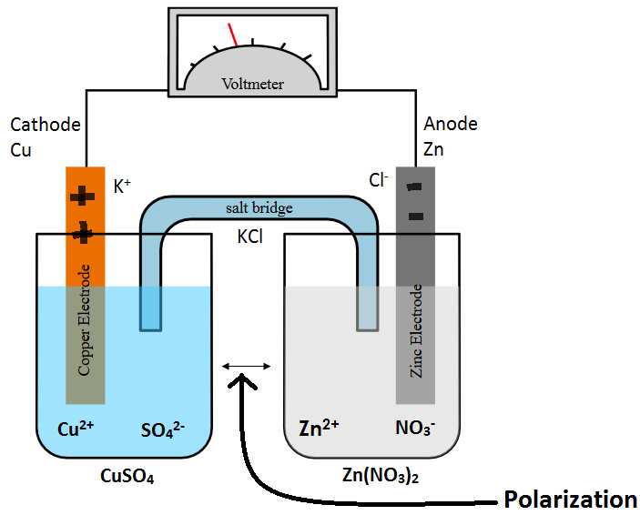

There are 3 types of Galvanic Cells:
- 2 Metal Electrodes
- Metal + Inert
- 2 Inert Electrodes

Two Metal Electrodes
Using the Standard Reduction Potential Table to predict the anodes and cathodes for the following:
Combination | Anode  (Lowest Voltage) | Cathode  (Highest Voltage) | Half-Reactions
Ni + Sn | Ni -0.25V | Sn -0.16V | $Ni→{Ni}^{2+}+2{ e}^{-} E^{o}=+0.25V$  ${Sn}^{2+}+2{ e}^{-}→Sn E^{o}=-0.16V$  Final Equation:  $$Ni+{Sn}^{2+}→{Ni}^{2+}+Sn ∆E^{o}=0.09V$$
Al + Zn | Al -1.66V | Zn -0.76V | $2∙\left(Al→{Al}^{3+}+3{ e}^{-}\right) E^{o}=+1.66V$  $3∙\left({Zn}^{2+}+2{ e}^{-}→Zn\right) E^{o}=-0.76V$  Final Equation:  $$2 Al+3{ Zn}^{2+}→{2 Al}^{3+}+3 Zn ∆E^{o}=0.90V$$
Sn + Al | Al -1.66V | Sn -0.16 | $2∙\left(Al→{Al}^{3+}+3{ e}^{-}\right) E^{o}=+1.66V$  $$3∙\left({Sn}^{2+}+2{ e}^{-}→Sn\right) E^{o}=-0.16V$$  Final Equation:  $$2 Al+3{ Sn}^{2+}→{2 Al}^{3+}+3 Sn ∆E^{o}=1.50V$$
Cu + Al | Al -1.66V | Cu +0.34V | $2∙\left(Al→{Al}^{3+}+3{ e}^{-}\right) E^{o}=+1.66V$  $$3∙\left({Cu}^{2+}+2{ e}^{-}→Cu\right) E^{o}=+0.34V$$  Final Equation:  $$2 Al+3{ Cu}^{2+}→{2 Al}^{3+}+3 Cu ∆E^{o}=2.00V$$
Ni + Zn | Zn -0.76V | Ni -0.25V | $${Zn}^{2+}+2{ e}^{-}→Zn E^{o}=+0.76V$$  $Ni→{Ni}^{2+}+2{ e}^{-} E^{o}=-0.25V$  Final Equation:  $$Ni+{Zn}^{2+}→{Ni}^{2+}+Zn ∆E^{o}=0.51V$$

Metal + inert electrodes
Terms | Definition (What the term means for this type of cell)
Inert | Non-reactive (Pt, Carbon)
Anode | Metal Electrode
Cathode | Reduction of ions

Ex. | Carbon + Metal Electrode  What reaction occurred in the solution (NaNO₃)?  $${NO}_{3}^{-}+3H^{+}+2e^{-}→{HNO}_{2}+H_{2}O E^{o}=+0.94V$$

An inert electrode is a metal submerged in an aqueous solution of ion compounds that transfers electrons rather than exchanging ions with the aqueous solution. It does not participate or interfere in the chemical reaction but serves as a source of electrons. Platinum is usually the metal used as an inert electrode. An active electrode is an electrode that can be oxidized or reduced in half reaction.
Anode: Fe²⁺ _{(aq)} → Fe³⁺_{(s)} + e⁻
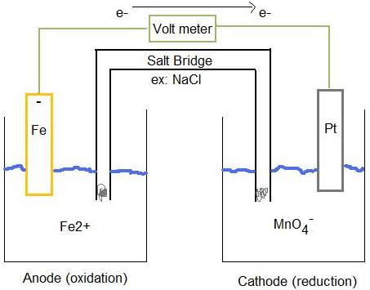
Cathode: MnO₄⁻_{(aq)} + 8H⁺ _{(aq)} + 5e⁻ → Mn²⁺ _{(aq)} + 4H₂O _{(l)}

Two Inert Electrodes
Inert non-reactive
Galvanic Cells are characterized by their ability to induce spontaneous reactions. However, the primary difference between the various types of Galvanic Cells is simply the type of electrode used. Specifically, the primary element found within the electrode.

Steps
- Find 2 equations in the Standard Reduction Potential Table that contain all of the ions
- Determine the anode and cathode
- Reverse anode reaction and sign on the voltage
- Balance the electrons
- Add the equations

Example 1
Consider the following combination of ions:
$$\text{Br}{\text{O}}_{\text{3}}^{\text{-}} {\text{H}}^{\text{+}} {\text{Br}}^{\text{-}} {\text{H}}_{\text{2}}\text{O }{\text{S}}_{\text{4}}{\text{O}}_{\text{6}}^{\text{2-}} {\text{S}}_{\text{2}}{\text{O}}_{\text{3}}^{\text{2-}}$$
- “Find 2 equations in the Standard Reduction Potential Table that contain all of the ions”
In this example, the two equations that contain all of the ions are:
- $\text{Br}{\text{O}}_{\text{3}}^{\text{-}}+6{\text{H}}^{\text{+}}+\text{6}{\text{e}}^{\text{-}} →{\text{Br}}^{\text{-}}+3{\text{H}}_{\text{2}}\text{O} E^{o}=+1.44$
- ${\text{S}}_{\text{4}}{\text{O}}_{\text{6}}^{\text{2-}}+2{\text{e}}^{\text{-}} →{\text{2 S}}_{\text{2}}{\text{O}}_{\text{3}}^{\text{2-}} E^{o}=+0.169$

- “Determine the anode and cathode”
Remember that the anode of a galvanic cell is the ion of the equation with the lowest voltage. Anode of a galvanic cell is where reduction occurs, thus it has to be lower on the Standard Reduction Potential table.
- Anode: ${\text{S}}_{\text{4}}{\text{O}}_{\text{6}}^{\text{2-}} E^{o}=+0.169$
- Cathode: $\text{Br}{\text{O}}_{\text{3}}^{\text{-}} E^{o}=+1.44$

- “Reverse anode reaction and sign on the voltage”
To reverse a reaction, the products of original anode equation become the reactants. Due to this, the sign on the voltage is reversed as well.
Original Equation:
$${\text{S}}_{\text{4}}{\text{O}}_{\text{6}}^{\text{2-}}+2{\text{e}}^{\text{-}} →{\text{2 S}}_{\text{2}}{\text{O}}_{\text{3}}^{\text{2-}} E^{o}=+0.169$$
Equation upon reversal:
$${{\text{2 S}}_{\text{2}}{\text{O}}_{\text{3}}^{\text{2- }}\text{→ S}}_{\text{4}}{\text{O}}_{\text{6}}^{\text{2-}}+2{\text{e}}^{\text{-}} E^{o}=-0.169$$
- “Balance electrons”
Let’s look at our 2 equations again.
$$\text{Br}{\text{O}}_{\text{3}}^{\text{-}}+6{\text{H}}^{\text{+}}+\text{6}{\text{e}}^{\text{-}} →{\text{Br}}^{\text{-}}+3{\text{H}}_{\text{2}}\text{O} E^{o}=+1.44$$
$${{\text{2 S}}_{\text{2}}{\text{O}}_{\text{3}}^{\text{2- }}\text{→ S}}_{\text{4}}{\text{O}}_{\text{6}}^{\text{2-}}+2{\text{e}}^{\text{-}} E^{o}=-0.169$$
There are 6e⁻ reacting, but only 2e⁻ being produced. Therefore, we must multiply the anode reaction by a factor of 3 $(Numeric Factor= \frac{Number of electrons reacting}{Number of electrons produced}=\frac{6}{2}=3)$ in order to balance the electrons. Remember NOT to multiply the voltage.
$$3∙{{[\text{2 S}}_{\text{2}}{\text{O}}_{\text{3}}^{\text{2- }}\text{→ S}}_{\text{4}}{\text{O}}_{\text{6}}^{\text{2-}}+2{\text{e}}^{\text{-}}] E^{o}=-0.169$$
$${={\text{6}\text{ S}}_{\text{2}}{\text{O}}_{\text{3}}^{\text{2- }}\text{→}\text{3}\text{ S}}_{\text{4}}{\text{O}}_{\text{6}}^{\text{2-}}+6{\text{e}}^{\text{-}} E^{o}=-0.169$$
After balancing:
$$\text{Br}{\text{O}}_{\text{3}}^{\text{-}}+6{\text{H}}^{\text{+}}+\text{6}{\text{e}}^{\text{-}} →{\text{Br}}^{\text{-}}+3{\text{H}}_{\text{2}}\text{O} E^{o}=+1.44$$
$${{\text{6 S}}_{\text{2}}{\text{O}}_{\text{3}}^{\text{2- }}\text{→3 S}}_{\text{4}}{\text{O}}_{\text{6}}^{\text{2-}}+6{\text{e}}^{\text{-}} E^{o}=-0.169$$
- “Add the equations”
$$\text{(}\text{Br}{\text{O}}_{\text{3}}^{\text{-}}+6{\text{H}}^{\text{+}}+\text{6}{\text{e}}^{\text{-}} →{\text{Br}}^{\text{-}}+3{\text{H}}_{\text{2}}\text{O} E^{o}=+1.44) + {({\text{6 S}}_{\text{2}}{\text{O}}_{\text{3}}^{\text{2- }}\text{→}\text{3}\text{ S}}_{\text{4}}{\text{O}}_{\text{6}}^{\text{2-}}+6{\text{e}}^{\text{-}} E^{o}=-0.169)$$
$$\text{Br}{\text{O}}_{\text{3}}^{\text{-}}+6{\text{H}}^{\text{+}}+ {\text{6 S}}_{\text{2}}{\text{O}}_{\text{3}}^{\text{2- }}+\text{6}{\text{e}}^{\text{-}}→{\text{Br}}^{\text{-}}+3{\text{H}}_{\text{2}}\text{O + }{\text{3}\text{ S}}_{\text{4}}{\text{O}}_{\text{6}}^{\text{2-}}+ \text{6}{\text{e}}^{\text{-}} ∆E^{o}=+1.44-0.169=+1.271$$
Final Equation:
$$\text{Br}{\text{O}}_{\text{3}}^{\text{-}}+6{\text{H}}^{\text{+}}+ {\text{6 S}}_{\text{2}}{\text{O}}_{\text{3}}^{\text{2- }}→{\text{Br}}^{\text{-}}+3{\text{H}}_{\text{2}}\text{O + }{\text{3}\text{ S}}_{\text{4}}{\text{O}}_{\text{6}}^{\text{2-}} ∆E^{o}=+1.271$$

Example 2
$$\text{Mn}{\text{O}}_{\text{4}}^{\text{-}} {\text{H}}^{\text{+}} {\text{Mn}}^{\text{2+}} {\text{H}}_{\text{2}}{\text{SO}}_{\text{3}} \text{S}{\text{O}}_{\text{4}}^{\text{2-}} {\text{H}}_{\text{2}}\text{O}$$
Cathode  Anode  After Reversal  Balancing e⁻ | $E^{o}=+1.49 \text{Mn}{\text{O}}_{\text{4}}^{\text{-}}+8{ \text{H}}^{\text{+}}+5 {\text{e}}^{\text{-}} → {\text{Mn}}^{\text{2+}}+4{ \text{H}}_{\text{2}}\text{O}$
$E^{o}=+0.17 \text{S}{\text{O}}_{\text{4}}^{\text{2-}}+4{ \text{H}}^{\text{+}}+2 {\text{e}}^{\text{-}} → {\text{H}}_{\text{2}}{\text{SO}}_{\text{3}}+{\text{H}}_{\text{2}}\text{O}$

$E^{o}=-0.17 {\text{H}}_{\text{2}}{\text{SO}}_{\text{3}}+{\text{H}}_{\text{2}}\text{O} →\text{S}{\text{O}}_{\text{4}}^{\text{2-}}+4{ \text{H}}^{\text{+}}+2 {\text{e}}^{\text{-}}$

$$2∙\text{[}\text{Mn}{\text{O}}_{\text{4}}^{\text{-}}+8{ \text{H}}^{\text{+}}+5 {\text{e}}^{\text{-}} → {\text{Mn}}^{\text{2+}}+4{ \text{H}}_{\text{2}}\text{O}\text{]}$$
$$5∙[{\text{H}}_{\text{2}}{\text{SO}}_{\text{3}}+{\text{H}}_{\text{2}}\text{O} →\text{S}{\text{O}}_{\text{4}}^{\text{2-}}+4{ \text{H}}^{\text{+}}+2 {\text{e}}^{\text{-}}]$$

$∆E^{o}$ | $$∆E^{o}=+1.49-0.17=+1.32$$
Add Equations  Final Equation | $$2\text{ Mn}{\text{O}}_{\text{4}}^{\text{-}}+5 {\text{H}}_{\text{2}}{\text{SO}}_{\text{3}}+5 {\text{H}}_{\text{2}}\text{O} +16 {\text{H}}^{\text{+}}→2{ \text{Mn}}^{\text{2+}}+8{ \text{H}}_{\text{2}}\text{O}+20 {\text{H}}^{\text{+}}+5 \text{S}{\text{O}}_{\text{4}}^{\text{2-}}$$  $$2\text{ Mn}{\text{O}}_{\text{4}}^{\text{-}}+5 {\text{H}}_{\text{2}}{\text{SO}}_{\text{3}}+5 {\text{H}}_{\text{2}}\text{O}→2{ \text{Mn}}^{\text{2+}}+8{ \text{H}}_{\text{2}}\text{O}+4{ \text{H}}^{\text{+}}+5 \text{S}{\text{O}}_{\text{4}}^{\text{2-}} ∆E^{o}=+1.32$$

